Humans

Research suggesting that a specialized cortical area is responsible for processing a specific kind of information has usually been seen as supporting a modularity position. Thus, proponents of a geometric module have been intrigued by data that the geometric layout of the environment is processedin a specific area of the human brain, namely the posterior tip of the parahippocampal gyrus and adjacent regions of the fusiform gyrus (Epstein and Kanwisher, 1998; Epstein, DeYoe, Press, Rosen, & Kanwisher, 2001; Epstein, Graham, & Downing, 2003; Epstein, Harris, Stanley, & Kanwisher, 1999). This area, shown in Figure J-17, has been termed the Parahippocampal Place Area (PPA).

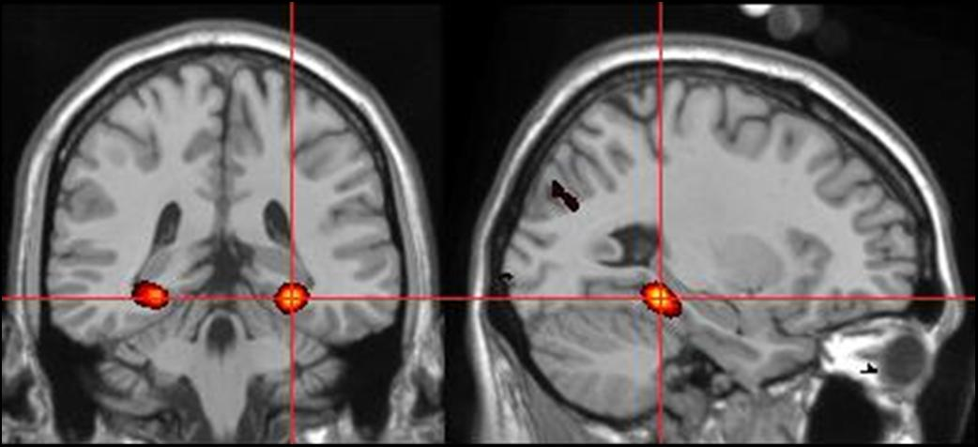
Figure J-17:
This and the next few images come from Russell Epstein.

Several findings led to the argument that the PPA is specialized for geometric information. First, perception of scenes (as shown at the left in Figure J-18) led to differential activation in the PPA, relative to perception of faces, houses or objects such as the blender shown at the right of Figure J-18 (Epstein & Kanwisher, 1998). This pattern was seen even when the subjects were not required to perform any tasks.

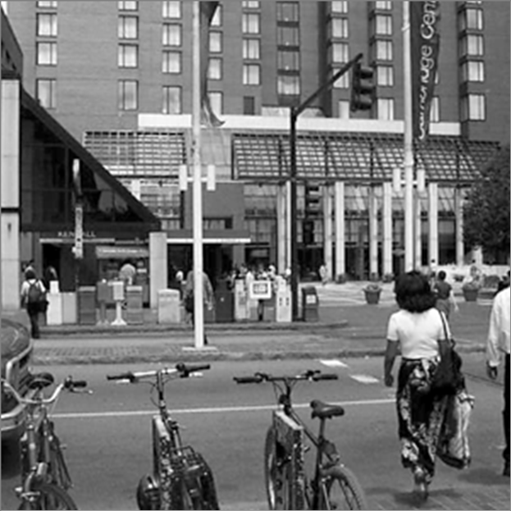 | > | 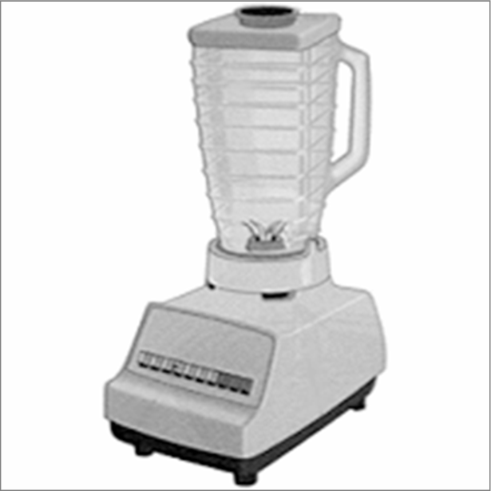
Figure J-18:
Scenes used by Epstein & Kanwisher (1998)

Second, coherent geometric structure seemed vital to PPA activation because fractured and rearranged versions of bare rooms did not elicit a response.
Third, activity in the PPA is not further increased when people feel as if they are moving in a scene, suggesting that it is more involved in geometric analysis than in planning routes or monitoring locomotion (Epstein et al., 1999).
Fourth, it is also interesting that there is evidence that the PPA seems to be viewpoint specificSpecifically, i
maging of PPA activity while people looked at scenes such as those in Figure J-19 showed that a change in viewpoint (middle row) led to as much activity as a complete change in place (at bottom) with both elevated relative to no-change control (at top). Viewpoint specificity might be helpful in using geometric information to reorient.

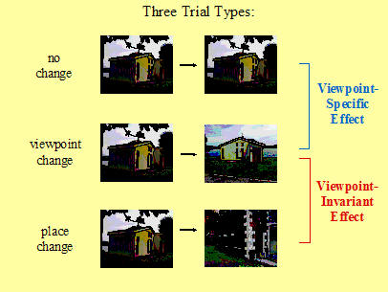
Figure J-19:

There are, however, alternative interpretations of the role of human parahippocampal cortex in spatial processing (Maguire, Burgess, et al. , 1998; Maguire, Frith, et al., 1998; see also Maguire, Burgess, & O’Keefe, 1999; O’Keefe et al., 1999) and hence doubts as to whether the PPA indicates the neurophysiological substrate of a geometric module. This group has imaged humans performing a variety of tasks such as navigating around a virtual town (see Figure J-20).
and has argued that the parahippocampal area is especially involved in locating objects in allocentric space. In fact, Burgess and O’Keefe (2003) suggest that the human parahippocampus is better termed a Spatial Scene Area than a Place Area.

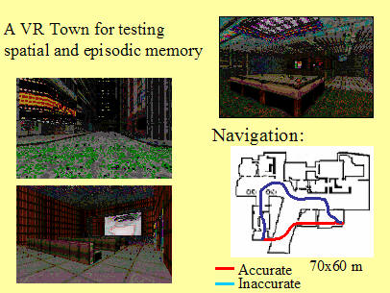
Figure J-20: Virtual Reality paradigm used by Burgess and colleagues. Picture courtesy of Neil Burgess.

Further evidence that the PPA is not the unique substrate for a geometric module comes from charting of place cells in the human hippocampus itself, cells that respond to people’s knowledge of their location independent of what objects they are facing or where they are trying to go. Ekstrom et al. (2003) conducted the first single-cell investigation of humans--7 patients with pharmacologically intractable epilepsy who were being observed with intra-cranial electrodes participated as taxi drivers in a VR navigation game in which they “drove” around nine buildings, such as the one shown in the upper left of Figure J-21, arraned in a regular grid as shown in the bottom right of Figure J-21, (courtesy of Michael Kahana). They picked up passengers and took them to one of the nine buildings.

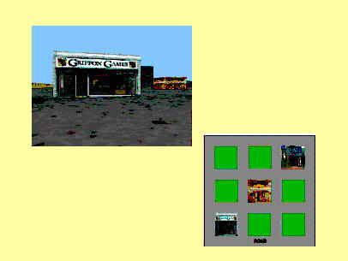
Figure J-21:
Cells were categorized as place cells if they responded when the patient was in a particular location in the grid, independent of what view was on the screen or what goal was being sought. Similarly cells could be categorized as view cells or as goal cells if they responded to particular views or goals but were not affected by the other two types of information or by interactions. Place cells predominated in the hippocampus (as shown in Figure J-22, courtesy of Michael Kahana). View cells predominated in the parahippocampus.

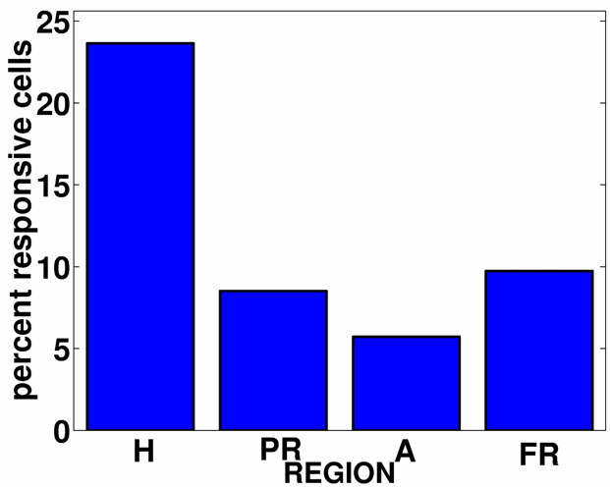
Figure J-22:
Ekstrom et al. data

